Mulesoft Anypoint Platform
Experiment 1
Problem statement:
Installation of AnyPoint Studio and Steps to create AnyPoint Platform credentials.
Solution:
Steps to install Anypoint Studio:
- To begin your development journey with MuleSoft, the first step is to install Anypoint Studio, which is the official IDE (Integrated Development Environment) provided by MuleSoft. It allows developers to design, test, and deploy Mule applications efficiently.
- Go to the official MuleSoft site: https://www.mulesoft.com/lp/dl/anypoint-mule-studio .
- 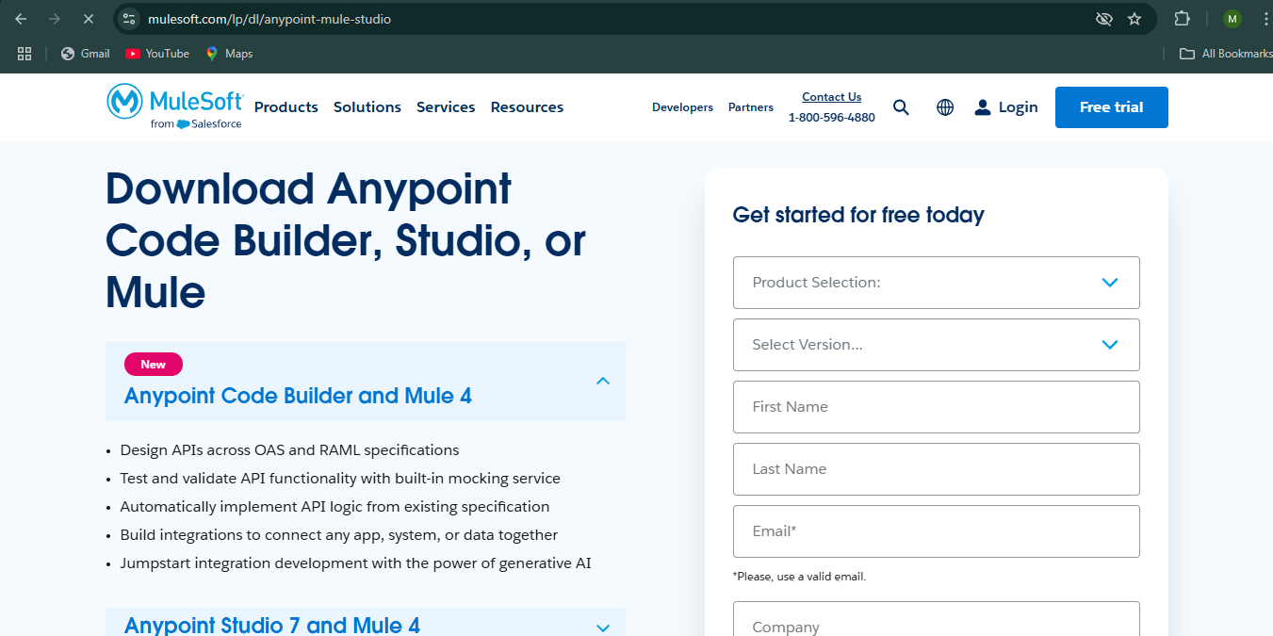
- You will be presented with a form asking for basic information such as your name, organization, email ID, and country. Fill out these details correctly. This information is used to personalize your download experience and track usage for trial purposes.
- After completing the form, click on the Download button. This action will begin downloading a .zip archive containing the Anypoint Studio installation package. Ensure your internet connection is stable, as the file size is typically over 1 GB.
- Next Extract all the files into C drive.

- Inside the extracted folder, locate the AnypointStudio.exe file and double-click it to launch the application.
- 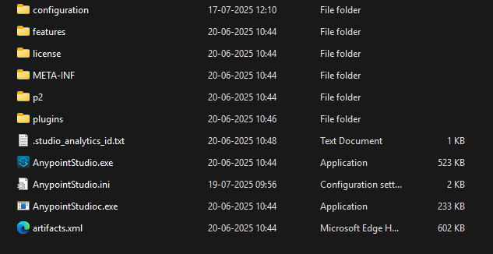
- In this click on the AnypointStudio.exe which will open the AnypointStudio.
- In that set a default location and click enter.
- Once initialized, the Studio environment loads and you're presented with a fully interactive IDE. You are now ready to start building APIs and integrations using MuleSoft’s powerful flow-based interface.
- 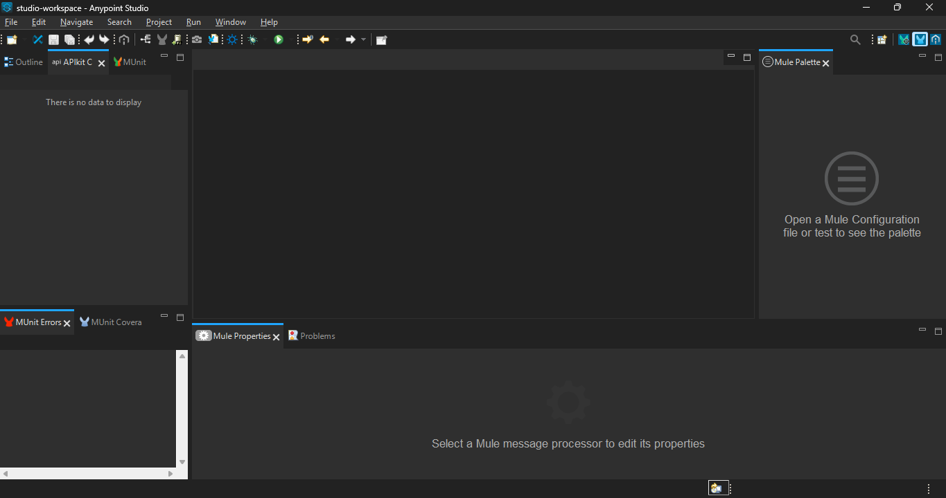

Steps to create Anypoint Platform credentials:
- MuleSoft’s Anypoint Platform is a unified integration platform for APIs, data, and applications. To access its capabilities like API Designer, Exchange, and API Manager, you need to create a developer account.
- To create Anypoint Platform credentials:
  - Go to https://www.mulesoft.com/ .
  - On the top right corner, click on the Free Trial button. This allows you to sign up for a trial account which gives access to the Anypoint Platform.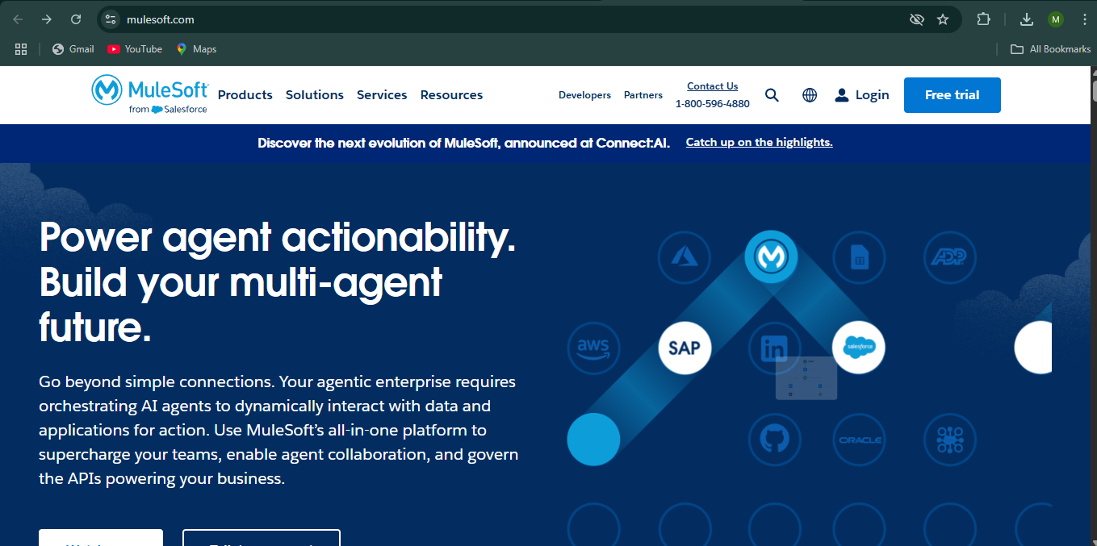
  - You will be redirected to a registration page where you must enter details such as:
    - Full Name
    - Email Address (preferably one you can verify)
    - Company/Organization name
    - Country
    - Password

  - 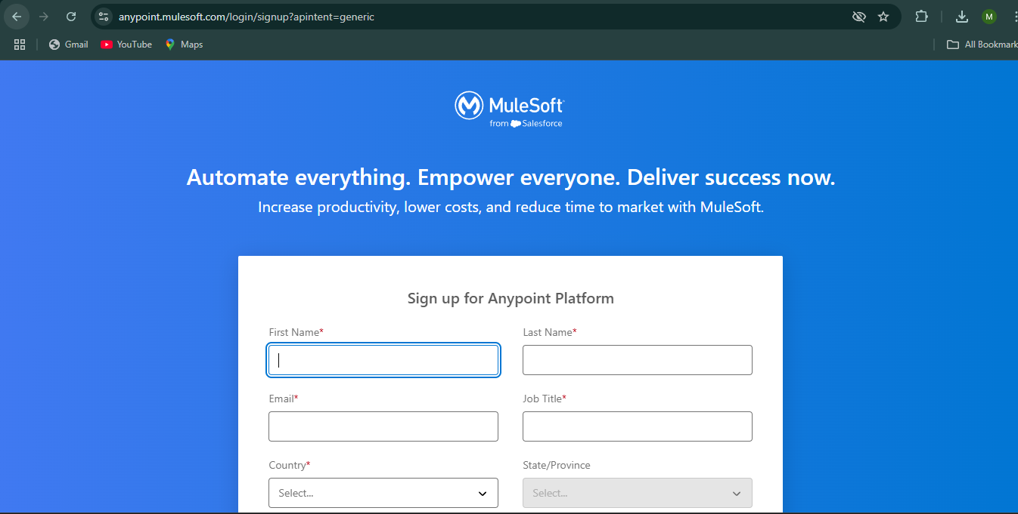
  - After filling in the necessary information, click on the Create Account button at the bottom of the form

  - An email will be sent to your registered email address for verification. Open the email and click on the Verify link to activate your account.
  - Once verified, you will be able to log in to the Anypoint Platform using the email and password you registered with.

  - 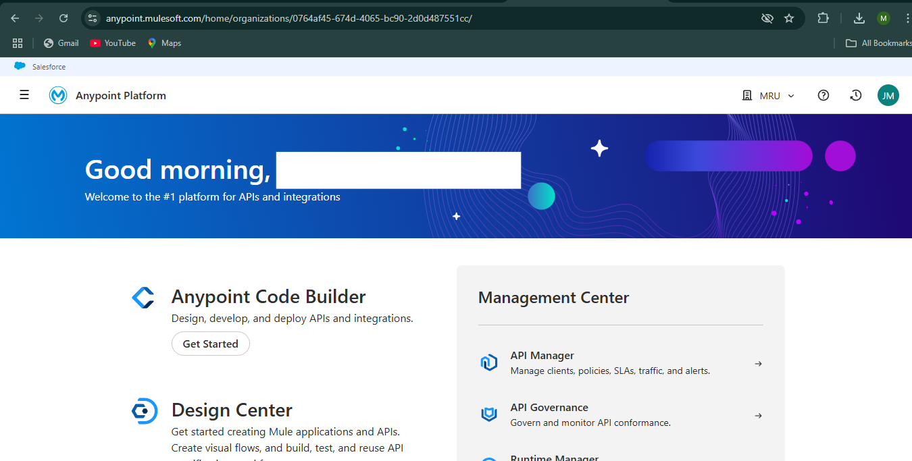
  - Upon logging in, you will see the Anypoint Platform dashboard, which contains various modules like API Designer, Exchange, API Manager, and more. From here, you can begin designing APIs, testing flows, managing policies, and publishing your assets to the Anypoint Exchange.

